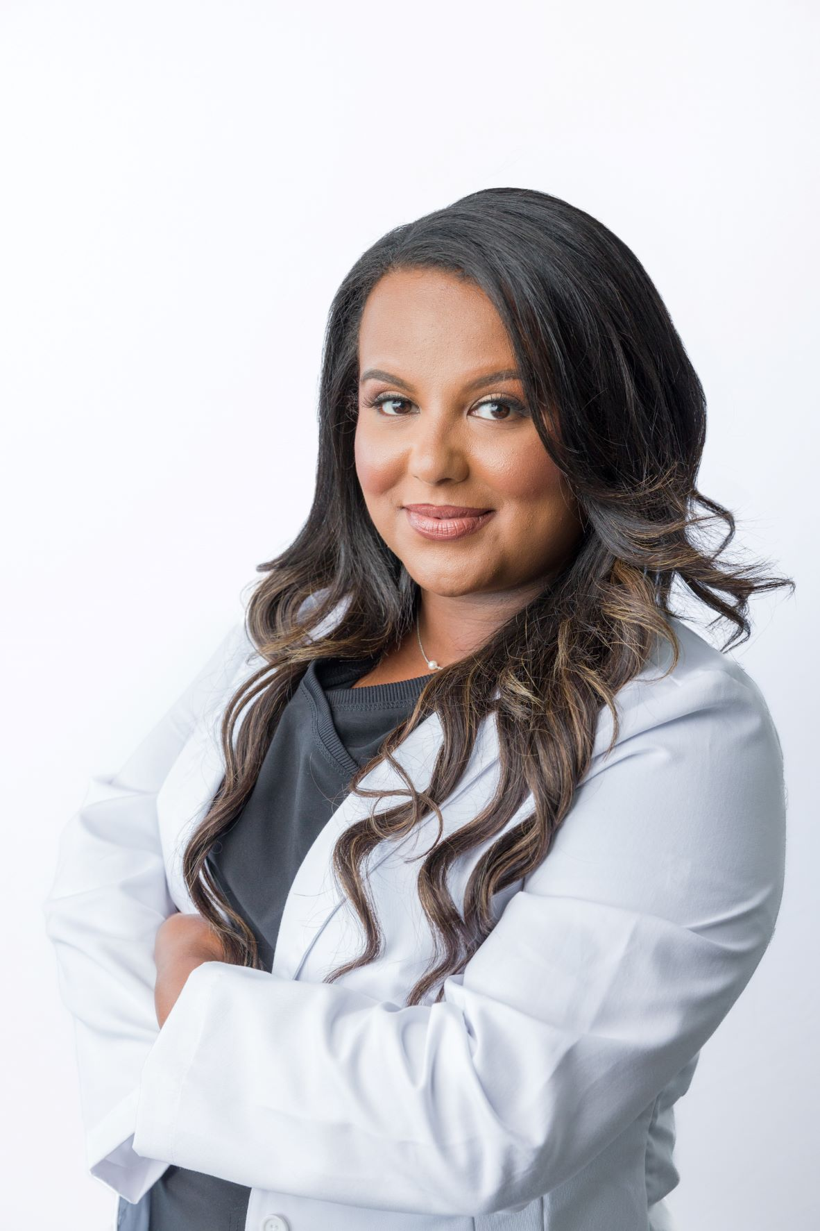 |  | DR. Liya Mohammed  D.D.S
Publications/Appearances  - Success Quarterly  - Confidence  - LNGFRM  - Dentistry 33  Professional Affiliations  - American Dental Academy (ADA)  - American /academy of cosmetic dentist (ACDA)  - New Jersey Dental association (NJDA)  - Hudson County Dental Society  Peer-Review  - Journal of American Dental Association (JADA),  - Clinical Implant Dentistry, and Related Research  - Special Care in Dentistry  PHONE:  6092141443  WEBSITE:  www.mysmiledental.org  EMAIL:  Lm1908@nyu.edu  Hobbies  Singing-Ethiopian Idol  Contestant/Finalist (2006) |  | EDUCATION  Progressive Orthodontic Seminars  2020 - 2022  Post-doctoral orthodontic program- Highest Honors  New York University College of Dentistry (NYUCD)  2010 - 2014  D.D.S Dentistry  Manhattanville College  2006-2010  B.Sc. Biochemistry- Castle Pin Award  WORK EXPERIENCE  My Smile Dental: Lead Dentist  2016–Current  - Managed operations in busy dental clinic, including instruction and delegation of dental hygienists, dental assistants, and office manager.  - Recognized for building robust relationships with patients and parents. Raised patient retention by 40%.  - Expert dentistry knowledge, including periodontics, oral and maxillofacial surgery, orthodontics, endodontics, and prosthodontics.  NY AVE Dental: Fulltime Dentist  2015–2016  Wyckoff Heights Medical Center: PGY-1  2014–2015  NYUCD: North East Regional Dental Board Exam (NERB) Tutor  2011  Tutored 3rd year dental Students with their NERB examination  Manhattanville College: Resident Assistant promoted to Resident Director  September 2007-May 2010  Assessed and responded to the needs of residents and counseled peers on personal, academic, and career concerns while adhering to college policies as a resident advisor/director  Manhattanville College: STEP Program Instructor  September 2007- May 2010  Tutored 25+ middle/high school and college students in basic chemistry, math and calculus  volunteer Experience  EmpowerGirlsNOW: Founder and President  2020 – Current  A NJ NPO: To Empower women and provide freedom through Education  NYU College of Dentistry: Student Ambassador  Sept 2012-2014  Ambassadors play a crucial role in the recruitment efforts of student applying for New York University's College of Dentistry Admissions. Ambassadors provide prospective students with authentic representations of the professional school experience at NYUCD.  NYU College of Dentistry: Women of Color in Dentistry Vice President of Associate Affairs  Sep 2013-2014  Women of Color in Dentistry has the mission of providing support to women of color of every ethnicity who choose to enter dental school in both the 4 year program as well as Advanced Placement.  Honors/Scholarships and Awards  Progressive Orthodontics, NJ, 2022  HIGHEST HONORS-Award  NYU College of Dentistry, New York, NY  Dental Dean's Merit Scholarship: Sept, 2010- 2014  Manhattanville College, Purchase, NY  Castle Pin Award: May, 2010(1 of 10 recipients from the whole graduating class)  The Castle Pin recognizes graduating seniors who have demonstrated leadership above and beyond the requirements of any role, job or scholarship.  KAPLAN Free DAT Prep Course: April, 2010  Duchesne Community Service Scholarship: Sep, 2006- May, 2010  International Leadership Scholarship: Sep, 2006- May, 2010  Board of Trustees Scholarship: Sep, 2006- May, 2010  Rewarding students of high academic achievement regardless of their financial need.  Research grant from Tri-Beta Nationals Honors Society: 2009, 2010 (1of 30 recipients in the whole North east region)  Beta Beta Beta (TriBeta) formally defines itself as “an honor and professional society for students of the biological sciences.” The functions of Beta Beta Beta (TriBeta) as a national organization range from publication of the national journal, BIOS, to recognition of outstanding individual and chapter accomplishments.  Honors Portfolio: Dec, 2009
 |  | REsearch
- Mohammed, L¹., Currimbhoy, M²., Sacks, P³., Guttenplan, J⁴. Comparison of BaP-induced Mutagenesis in Monolayer and 3-Dimensional Culture Models. (2012) International Association of Dental Research. https://iadr.abstractarchives.com/abstract/2012tampa-158338/comparison-of-bap-induced-mutagenesis-in-monolayer-and-3-dimensional-culture-models
- Gupta, V¹., Mohammed, L²., Deep, R³., Penugonda, B⁴. Effect of Microwave Cycles on Surface Roughness/Microhardness of Acrylic Dentures. (2014) International Association of Dental Research. https://iadr.abstractarchives.com/abstract/43am-186963/effect-of-microwave-cycles-on-surface-roughnessmicrohardness-of-acrylic-dentures
- Bettica, A.,¹, Gomez, M.,¹, Wondimu, E.,², Mohammed, L.³ . Correlations between growth rate inhibition and estrogen levels after combined bioantioxidant treatments of carnosol and 6-gingerol with reveromycin A in MCF-7 human mammary and RL95-2 human endometrial adenocarcinoma cells in vitro.(2010)

